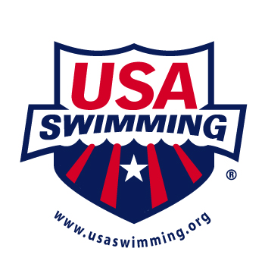

ARTICLE 101

INDIVIDUAL STROKES AND RELAYS

101.4 FREESTYLE

.1 Start — The forward start shall be used.

.2 Stroke — In an event designated freestyle, the swimmer may swim any style, except that in a
medley relay or an individual medley event, freestyle means any style other than butterfly,
breaststroke or backstroke. Some part of the swimmer must break the surface of the water
throughout the race, except it shall be permissible for the swimmer to be completely submerged
during the turn and for a distance of not more than 15 meters (16.4 yards) after the
start and each turn. By that point the head must have broken the surface.

.3 Turns — Upon completion of each length the swimmer must touch the wall.

.4 Finish — The swimmer shall have finished the race when any part of his person touches the
wall after completing the prescribed distance.

